International School of Neurological Sciences of Venice
President: Giuliano Avanzini – Director: Francesco Paladin

5th International Course on Epilepsy:
Surgically remediable epilepsies
28 July – 8 August, 2006
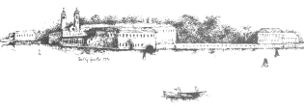
Venice International University, San Servolo, Venice, Italy

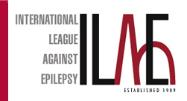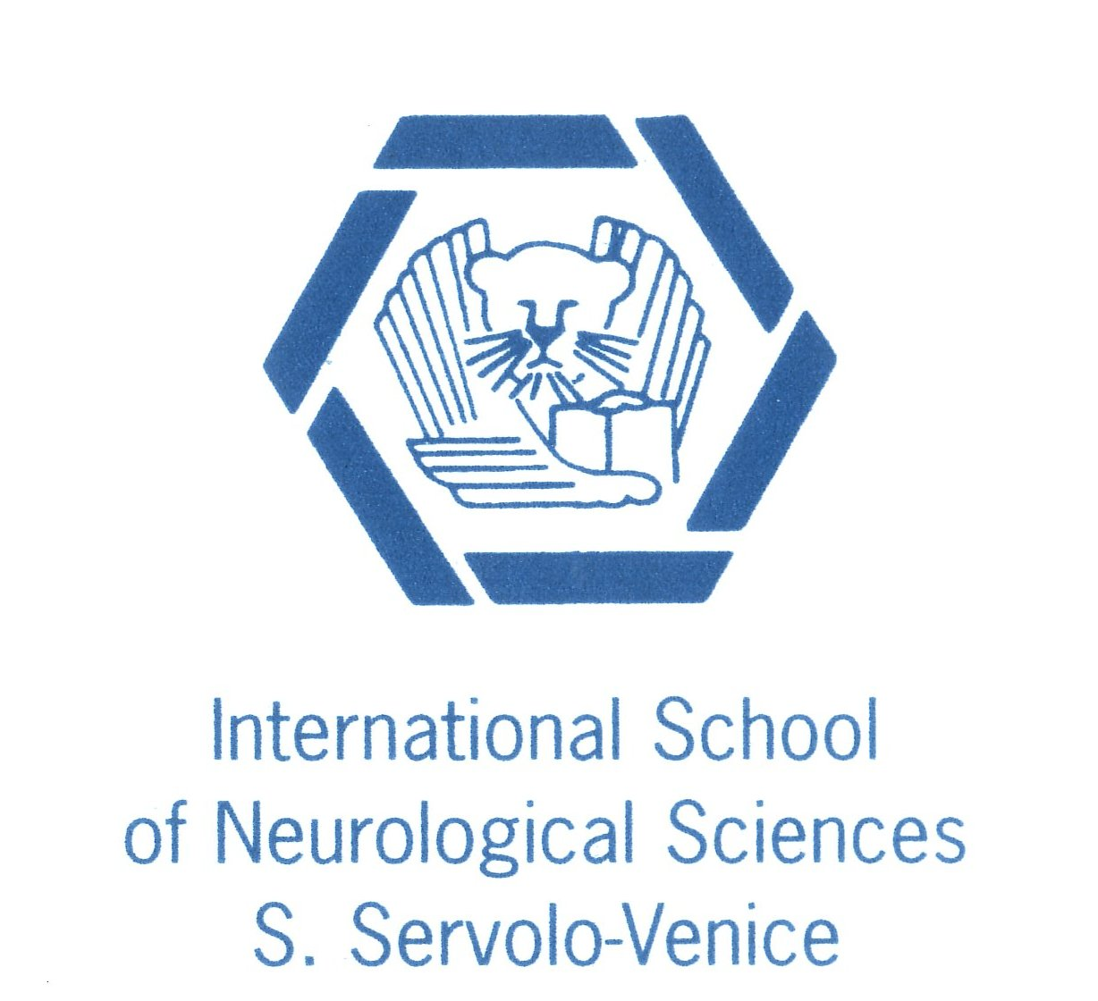

Course directors: Heinz-Gregor Wieser (Switzerland) and Giorgio Lo Russo (Italy)

Aim of the course is to teach attendees to: (1) utilize basic knowledge for imaging and electrophysiological study of candidate patients to epilepsy surgery; (2) describe nature and evolution of surgically remediable epilepsies; (3) recognize and select patients with drug-resistant epilepsy that may benefit of surgical approach; (4) plan neurophysiological, video EEG and imaging investigations and interpret their results in the clinical context; (5) run and manage a team that collaborate in a Epilepsy Surgery Unit. The course is primarily targeted at neurologists, neuropediatricians, neurophysiologists, neuroradiologists and neurosurgeons interested in the pathophysiology, diagnosis and management of pharmacoresistant epilepsies, and in research programs implementing in an epilepsy surgery unit.
Specific didactic material and equipment for practical sessions will be prepared, including EEGs and video EEGs, MRI, CT and angiographic films, software for EEG and experimental electrophysiological analysis. Students will be allowed to freely access the didactic material a computer room and in other dedicated spaces.
The course is part of the EPILEARN program approved by the Marie Curie Training Courses of the European Commission.

Provisional faculty:
Avanzini, Bernasconi, Bottini, Chauvel, Colombo, de Curtis, Delalande, Dravet, Duncan, Elger, Engel, Francione, Halasz, Holthausen, Kälviäinen, Lo Russo, Maccagnano, Martins Da Silva, Mathern, Najm, Özkara, Paladin, Pitkanen, Plouin, Spreafico, Tassi, Triki, Wieser, Wolf

Registration fee: 1,600 euro in single room; 1,300 euro in twin-bedded room. The registration fee includes:
- 12 nights accommodation
- full board and coffee breaks for the entire duration of the course
- access to the course and to the Venice International University facilities
- course syllabus
Financial support will be available for a limited number of young and senior applicants (up to 4 years and up to 10 after completion of their educational training, respectively).

For further information, please visit the ILAE, EUREPA and VIU web sites:
www.ilae-epilepsy.org, www.epilepsy-academy.org, www.univiu.org, www.isnvenice.com
Please send application form and attachments by March 31, 2006, preferably via e-mail,
to the course secretary: Metella Paterlini, epilepsysummercourse@univiu.org, fax +39-02-700445211

